MOHAMMAD SHAIK BASHA

192111459

3.CONNECTIVITY PROGRAM FOR PAYROLL SYSTEM

FORM:-

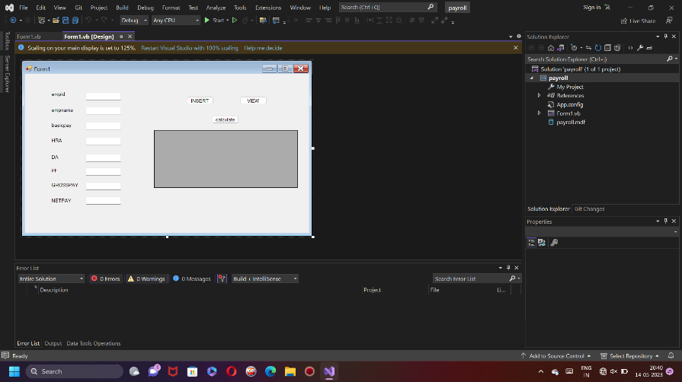

DATABASE:-

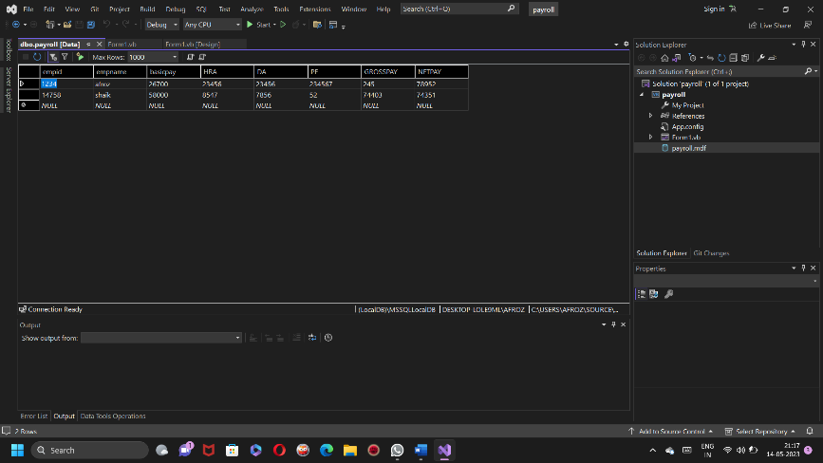

CODE:-

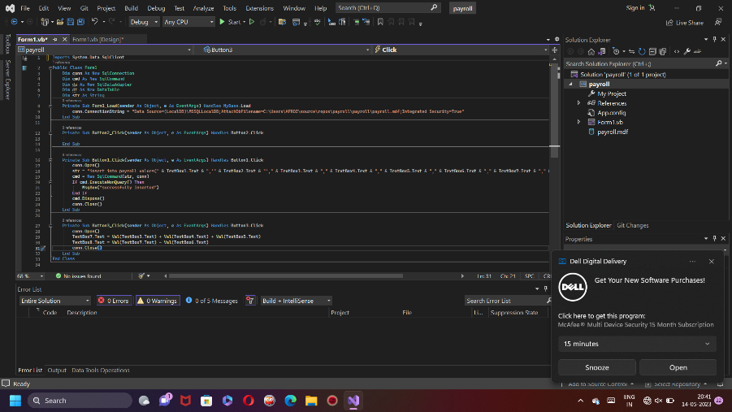

OUTPUT:-

